Short term plan: term 3

Unit: 5 Hot and Cold |  | Lesson 33
Teacher name:

Date:
Grade: 4 |  | Number present: | absent:
Lesson title | Weather 1
Learning objectives | 4.1.9.1 understand spoken words related to a limited range of general and educational topics;  4.2.1.1 compose simple sentences about oneself on a wide range of general topics;
Lesson objectives | Learners will be able to:  - talk about the weather.  - talk about summer and winter activities.
Value links | "Law and Order"  Know the basics of the legal system and human rights
Plan

Stages / Time | Teachers actions | Students actions | Assessment criteria | Resources
Beginning of the lesson  Warming-up    3 min.  Pre-learning  «Brainstorming» method  7 min. | Organization moment :  1.Greeting.  Ask about the weather.  The teacher sets the lesson objectives, letting students know what to anticipate from the lesson.  Warming up  Where are you from?  How old are you?  What color is it?  How many students are there in class?  What day of the week today?  Lead – In  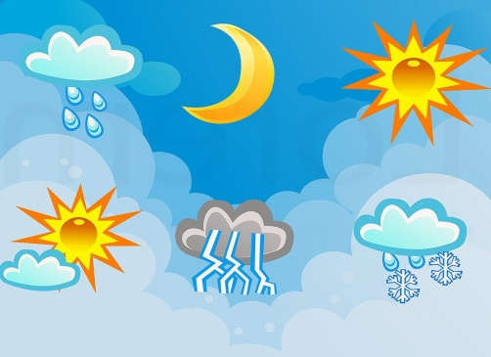 | Students of the class are listed.  Students' attention is drawn to the lesson.  Students say different words from the picture  Learners answer the questions  What is the weather today?  What was the weather yesterday? | The teacher to assess learners for their ability.  “Good job!  Well done!”  Formative Assessment  Good job!  Descriptor:  - remembers the lesson passed  Point 1  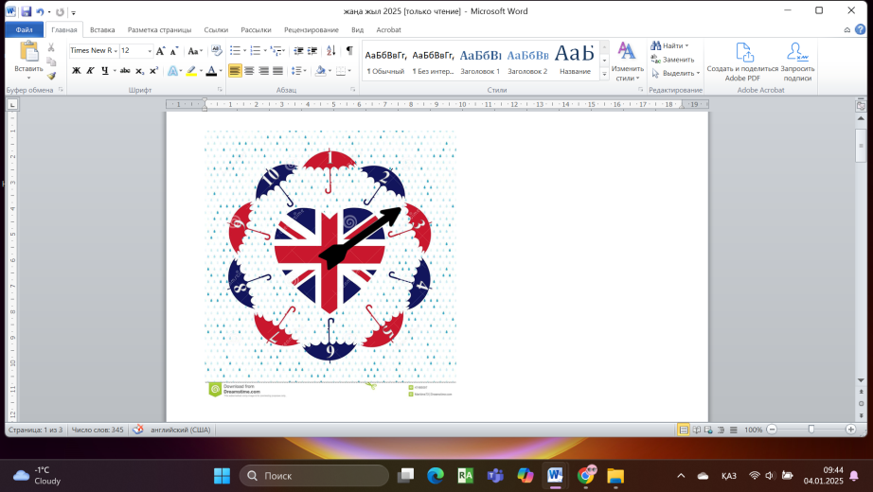 | Pictures
Middle of the lesson  Presentation part.  30 min | Ex:1 P:69  Look at the picture. Answer the questions.  Refer the pupils to the pictures and have a picture discussion. Elicit what season it is, what's the weather like, what the children are doing and what they're wearing (e.g. Is it winter or summer? Is it cold or hot? etc).  Explain the activity. Go through the questions and elicit/explain any unknown vocabulary. Allow the pupil's some time to answer the questions. Check their answers.  Ex: 2 P: 69  Put the flashcards up on the board. Point to the flashcards, one at a time, and say the corresponding phrases. The pupils repeat chorally and/or individually. Point to them in random order. Ask individual pupils to name them. Ask the rest of the class for verification.  Play the CD. The pupils listen, point to the words and repeat. If you wish, play the CD again pausing after each phrase. The pupils repeat chorally and/or individually  Ex: 3 P: 69  Write on the board a summer activity and a winter activity. Ask the pupils What do you do in summer? Elicit answers (e.g. I go swimming.). Give verification to the pupils by saying (Swimming) is a summer activity. Repeat the same in order to elicit winter activities.  Explain the activity. Go through the prompts and elicit/explain any unknown words. Allow the pupils some time to complete the activity. Check their answers. | learners look at the picture and answer the question  ANSWERS  1 It's winter.  2 It's cold.  3 They're wearing jackets, helmets and gloves.  4 New Year.  learners listen, point and repeat  ANSWERS  Students own answer  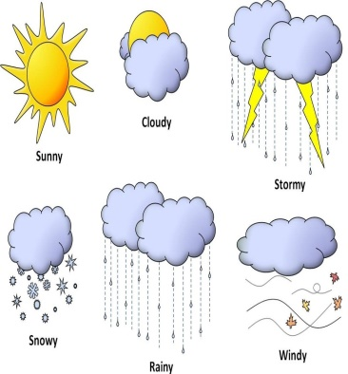  learners read and match. Then say.  ANSWERS  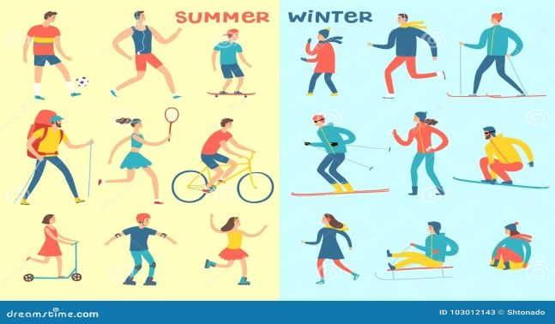  A summer activity: surfing, skating, camping A winter activity: skiing, snowboarding | Descriptor:  - look at the picture  - answer the question  Total: 3 point  Differentiation: «Verbal support» method is used to help Ss use new words in the sentences.  Descriptor:  - point to the flashcards  - ask individual to name them  Total: 3 point  Descriptor:  - read and match  Total: 3 point  -Make CCQ questions Yes / No |   Card  Worksheet  Students book
End of the lesson  5 min | FEEDBACK  Learners provide feedback on what they have learned at the lesson.  Ex: P:  Home task:  Write the days | 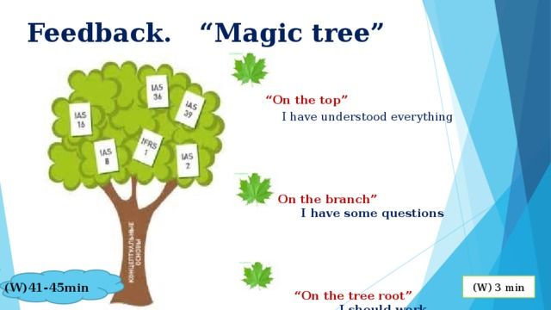 |  | Poster Success  

Short term plan: term 3

Unit 5: Hot and Cold |  | Lesson 34
Teacher name:

Date:
Grade: 4 |  | Number present: | absent:
Lesson title | Camping Safety
Learning objectives | 4.3.5.1 understand the main ideas of short normal texts on a wide range of general and academic topics using context clues;  4.4.5.1 connect sentences using basic phrases with little support;
Lesson objectives | Learners will be able to:  - to talk about camping and camping safety
Value links | "Law and Order"  Observance of norms and rules of order and justice understand the need
Plan

Stages / Time | Teachers actions | Students actions | Assessment criteria | Resources
Beginning of the lesson  Warming-up  3 min  Pre-learning  «Brainstorming» method  7 min. | Organization moment :  1.Greeting.  Ask about the weather.  The teacher sets the lesson objectives, letting students know what to anticipate from the lesson.  Warming up  Where are you from?  How old are you?  What color is it?  How many students are there in class?  What day of the week today?  Ask a few pupils to stand up and stand in a row. Ask the rest of the class questions to revise the ordinals.  Lead – In  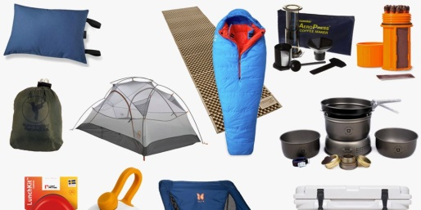 | Students of the class are listed.  Students' attention is drawn to the lesson.  Determines the topic and purpose of the lesson  Learners remember previous lesson vocabulary  Students say different words from the picture  Answer the question. | The teacher to assess learners for their ability.  “Good job!  Well done!”  Formative Assessment  Good job! | Pictures
Middle of the lesson  Presentation part.  30 min | Ex:5 P:70  Put up the Camping poster on the board. Point to the items, one at a time, and say the corresponding words. The pupils repeat, chorally and/or individually. Point to each item in random order. Ask individual pupils to name them.  The pupils read the words and match them to the pictures. Allow the pupils some time to complete the activity. Then they listen again and check their answers.  Ex: 6 P: 70  Explain the activity. Allow the pupils enough time to complete the activity. Check their answers.  Ex: 7 P: 71  Say and write on the board: You must do your homework. You mustn't throw rubbish. The pupils repeat, chorally and/or individually. Underline the words in bold and explain/elicit that these are modal verbs. Explain that we use must for obligation and mustn't for prohibition. Then say and write on the board: You have to study for the test. You don't have to wear a jacket. The pupils repeat, chorally and/or individually. Underline the words in bold and explain that we use have to for necessity and don't have to for lack of necessity. Explain that the modal verbs are the same for all persons | Pupils match the words to the pictures. Then listen and check?  ANSWERS  2 a  3 b  4 g  5 f  6 h  7 d  8 c  9 J  10 I  Pupils read and find the words.  ANSWERS  2 firewood  3 whistle  4 campfire  5 camp stove  6 rope  7 blanket  8 penknife  9 fishing rod  10 cool box  Pupils complete the sentences. Use: must or mustn't.  ANSWERS  2 must  3 must  4 mustn't  5 must  6 mustn't  7 must  8 mustn't | Descriptor:  - match the words to the pictures  - ask individual pupils to name them  Total: 3 point  Descriptor:  - read and find the words.  -complete the sentences  Total: 3 point  Descriptor:  - complete the sentences  - can use: must or mustn't.  Total: 1 point  -Make CCQ questions Yes / No  Total: 10 point | Card  Worksheet  Students book
End of the lesson  5 min | FEEDBACK  Learners provide feedback on what they have learned at the lesson.  Ex: P:  Home task:  Write the days |  |  | Poster Success

Short term plan: term 3

Unit 5: Hot and Cold |  | Lesson 35
Teacher name:

Date:
Grade: 4 |  | Number present: | absent:
Lesson title | Camping Safety
Learning objectives | 4.1.9.1 understand spoken words related to a limited range of general and educational topics;  4.2.1.1 compose simple sentences about oneself on a wide range of general topics;
Lesson objectives | Learners will be able to:  - develop listening and reading comprehension skills through a story  - practice talking about camping  - learn how to distinguish between and pronounce the long vowel /ai/ with two different spellings (-igh, -y).
Value links | "Law and Order"  Ensuring the protection and safety of society understand the importance of law and order as
Plan

Stages / Time | Teachers actions | Students actions | Assessment criteria | Resources
Beginning of the lesson  Warming-up  3 min  Pre-learning  «Brainstorming» method  7 min. | Organization moment :  1.Greeting.  Ask about the weather.  The teacher sets the lesson objectives, letting students know what to anticipate from the lesson.  Warming up  Where are you from?  How old are you?  What color is it?  How many students are there in class?  What day of the week today?  revise the vocabulary from the previous  Lead – In  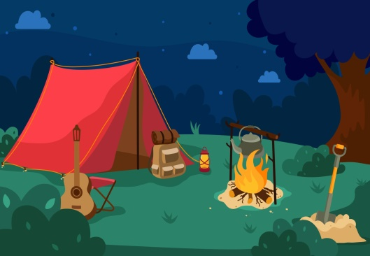 | Students of the class are listed.  Students' attention is drawn to the lesson.  Learners remember previous lesson vocabulary  Determines the topic and purpose of the lesson  Students say different words from the picture | The teacher to assess learners for their ability.  “Good job!  Well done!”  Formative Assessment  Good job!  Descriptor:  - can tell the time  Point 1 | Pictures
Middle of the lesson  Presentation part.  30 min | Ex:9 P: 72  Go through the pictures of the story and set the scene by asking the pupils questions about what they can see in the pictures.  teacher: (pointing to the firewood in picture 3) What's this?  Class: Firewood. Etc  Ex: 10 P: 73  Allow the pupils some time to read the story again silently and complete the activity. Check their answers.  Ex: 11 P: 73  Allow the pupils some time to read the story again. Then they complete the activity. Check their answers.  Ex: 13 P: 73  Refer the pupils to the picture and the dialogue. Play the CD. The pupils listen and follow along. Pause the CD for the pupils to repeat, chorally and/or individually. The pupils, in pairs, act out similar dialogues about themselves. Go around the classroom providing any necessary help. Ask some pairs to come to the front of the classroom and act out the dialogue. If you wish, write the following on the board so the pupils can refer to it while they are completing the activity.  Ex: 14 P: 73  Refer the pupils to the pictures. Point to knight and say: /ar/-knight. The pupils repeat, chorally and/or individually. Check their pronunciation. Repeat the procedure for light. Point to the picture of spy and say: /a/-spy. Repeat the procedure for sky. Explain the spelling differences (-igh, -y). | Pupils listen and read.  ANSWERS  Students own answer  Pupils read the story again and say if the sentences are True or False.  ANSWERS  1 False  2 True  3 False  4 True  5 False  Pupils read the story again and cap match.  ANSWERS  1 d  2 c  3 a  4 b  Pupils talking point. Listen and read. Make a new dialogue with your friend.  ANSWERS  Dana: I love camping.  Ulan: Me, too! Let's get everything ready. We mus collect the firewood.  Dana: Can I bring water from the river?  Ulan: Yes, it's not far. And we must cook on the camp stove, too!  Dana: I can do that  Pupils listen, point and repeat.  ANSWERS  igh: night, fight, right  y: fly, my, try | Descriptor:  - listen and read  Total: 2 point  Descriptor:  - read the story  - say if the sentences are True or False.  Total: 2 point  Descriptor:  - read the story  - complete the activity  Total: 1 point  Descriptor:  - listen and read  -create new dialogue  Total: 1 point  -Make CCQ questions Yes / No | Card  Worksheet
End of the lesson  5 min | FEEDBACK  Learners provide feedback on what they have learned at the lesson.  Ex:  Home task: |  |  | Poster Success
Short term plan: term 3

Unit 5: Hot and Cold |  | Lesson 36
Teacher name:

Date:
Grade: 4 |  | Number present: | absent:
Lesson title | Weather 2
Learning objectives | 4.3.6.1 understand basic information and detail in short simple texts about a wide range of general and learning topics with little support;  4.4.7.1 write many common words correctly when doing written work on their own;
Lesson objectives | Learners will be able to:  - to talk about weather and natural disasters.
Value links | "Law and Order"  Know the basics of the legal system and human rights
Plan

Stages / Time | Teachers actions | Students actions | Assessment criteria | Resources
Beginning of the lesson  Warming-up  3 min  Pre-learning  «Brainstorming» method  7 min. | Organization moment :  1.Greeting.  Ask about the weather.  The teacher sets the lesson objectives, letting students know what to anticipate from the lesson.  Warming up  Where are you from?  How old are you?  What color is it?  How many students are there in class?  What day of the week today?  revise the language from the previous lesson  Lead – In   | Students of the class are listed.  Students' attention is drawn to the lesson.  Learners talk about daily routines previous lesson vocabulary  Determines the topic and purpose of the lesson  Students say different words from the picture | The teacher to assess learners for their ability.  “Good job!  Well done!”  Formative Assessment  Good job!  Descriptor:  - talk about daily routines  Point 1 | Pictures
Middle of the lesson  Presentation part.  30 min | Ex:16 P:74  Put the Weather poster up on the board. Point to the items, one at a time, and say the corresponding words. The pupils repeat, chorally and/or individually. Point to each item in random order. Ask individual pupils to name them.  Ex: 17 P: 74  Read aloud the example and explain the activity. Explain that the dialogues are clues to find the correct answer. Go through the sentences and elicit/explain any unknown words. Allow the pupils some time to complete the activity. Check their answers.  Ex: 18 P: 75  Briefly revise the modal can. Explain that it is the same for all persons. Then, say and write on the board: Can you close the door please? Yes, I can. The pupils repeat chorally and/or individually. Underline the word in bold and explain that we use can for requests. Then, say and write on the board: Can I go out, dad? No, you can't. The pupils repeat chorally and/or individually. Underline the word in bold and explain that we also use can to ask for permission.  Go through the Study spot section briefly. Read the example and explain the activity. Go through the prompts and elicit/explain any unknown words. Allow the pupils some time to complete the activity. Check their answers.  Ex: 19 P: 75  Read aloud the example and explain the activity Allow the pupils some time to complete it. Check their answers. | Pupils look, choose and write. Then listen and check.  ANSWERS  B avalanche  C storm  D flood  F tornado  E hail  Pupils match the short dialogues to some of the words  ANSWERS  2 flood  3 avalanche  4 hail  Pupils make sentences.  ANSWERS  2 Can you send an email for me, please?  3 Can you close all the windows, please?  4 Can we leave early?  Pupils complete. Then act out  ANSWERS  2 Yes, you can.  3 No. you can't.  4 No, you can't. | Descriptor:  - repeat, chorally and/or individually  - Ask individual pupils to name them  Total: 2 point  Descriptor:  - Read aloud the example  - match the short dialogues  Total: 2 point  Descriptor:  - make sentences.  - underline the word in bold  Total: 2 point  Descriptor:  - read aloud the example  - act out  Total: 2 point  -Make CCQ questions Yes / No | Card  Worksheet  Students book
End of the lesson  5 min | FEEDBACK  Learners provide feedback on what they have learned at the lesson.  Ex:  Home task: |  |  | Poster Success

Short term plan: term 3

Unit 5: Hot and Cold |  | Lesson 37
Teacher name:

Date:
Grade: 4 |  | Number present: | absent:
Lesson title | Volcanoes
Learning objectives | 4.3.5.1 understand the main ideas of short normal texts on a wide range of general and academic topics using context clues;  4.4.2.1 use of a continuous letter while performing a limited amount of written work;
Lesson objectives | Learners will be able to:  - to revise weather and camping;  - to talk about volcanoes;  - to write about a campsite in my country;  - to develop the pupils' listening skills through a song
Value links | "Law and Order"  Observance of norms and rules of order and justice understand the need
Plan

Stages / Time | Teachers actions | Students actions | Assessment criteria | Resources
Beginning of the lesson  Warming-up  3 min  Pre-learning  «Brainstorming» method  7 min. | Organization moment :  1.Greeting.  Ask about the weather.  The teacher sets the lesson objectives, letting students know what to anticipate from the lesson.  Warming up  Where are you from?  How old are you?  What color is it?  How many students are there in class?  What day of the week today?  Revise the vocabulary from the previous lesson  Lead – In   | Students of the class are listed.  Students' attention is drawn to the lesson.  Learners talk about days of the week previous lesson vocabulary  Determines the topic and purpose of the lesson  Students say different words from the picture | The teacher to assess learners for their ability.  “Good job!  Well done!”  Formative Assessment  Good job!  Descriptor:  - talk about days of the we  Total: 1 point | Pictures
Middle of the lesson  Presentation part.  30 min | Ex:21 P:76  Explain the activity. Allow the pupils some time to read the text and underline the correct words. Play the CD. The pupils listen and check their answers.  Ex: 22 P: 76  Read aloud the title and elicit from the pupils what they know about volcanoes. Explain the activity. Go through the sentences and elicit/explain any unknown words. Play the CD. The pupils listen and circle the correct word/phrase. Check their answers.  Ex: 23 P: 77  Refer the pupils to the picture. Ask: What's the weather like in London Town? Elicit: It's windy and rainy. Then say as you mime: It's a windy day in London Town, a windy, windy day. The pupils repeat chorally and/or individually. Repeat with rainy.  Play the CD. The pupils listen and follow along in their books. Divide the class into two groups. Assign a verse to each group. Play the CD. The pupils listen and sing the corresponding verse.  Ex: 24 P: 77  Explain the activity. Allow the pupils 3 minutes to write their answers. Ask individual pupils to report back to the class. | Pupils read and underline. Then listen and check.  ANSWERS  2 eighty  4 have  6 up  3 have  5 or  Pupils listen and circle.  ANSWERS  2 Hawaii  3 Pacific  4 There aren't any  5 Etna  Pupils Let’s Sing!  ANSWERS  Sing a song  Pupils in three minutes, write  ANSWERS  1 hot, cold, foggy, windy, sunny  2 skiing, snowboarding  3 swimming, surfing, camping  4 rope, first-aid kit, cool box, whistle  5 go near wild animals, go for a walk alone | Descriptor:  - read the text  - underline the correct words  - listen and check  Total: 3 point  Descriptor:  - read aloud the title  - listen and circle the correct word/phrase  Total: 2 point  Descriptor:  - Sing a song  Total: 1 point  Descriptor:  - in three minutes, write  Total: 2 point  -Make CCQ questions Yes / No  Total: 10 point | Card  Worksheet  Vocabulary card
End of the lesson  5 min | FEEDBACK  Learners provide feedback on what they have learned at the lesson.  Ex:  Home task: |  |  | Poster Success

Short term plan: term 3

Unit 5: Hot and Cold |  | Lesson 38
Teacher name:

Date:
Grade: 4 |  | Number present: | absent:
Lesson title | Time for CLIL: snow and ice
Learning objectives | 4.3.6.1 understand basic information and detail in short simple texts about a wide range of general and learning topics with little support;  4.4.2.1 use of a continuous letter while performing a limited amount of written work;
Lesson objectives | Learners will be able to:  - To explore other subject areas (Geography)  - to talk about snow and ice.
Value links | "Law and Order"  Ensuring the protection and safety of society understand the importance of law and order as
Plan

Stages / Time | Teachers actions | Students actions | Assessment criteria | Resources
Beginning of the lesson  Warming-up  3 min  Pre-learning  «Brainstorming» method  7 min. | Organization moment :  1.Greeting.  Ask about the weather.  The teacher sets the lesson objectives, letting students know what to anticipate from the lesson.  Warming up  Where are you from?  How old are you?  What color is it?  How many students are there in class?  What day of the week today?  Revise the language of the previous lesson.  Lead – In   | Students of the class are listed.  Students' attention is drawn to the lesson.  Determines the topic and purpose of the lesson  Learners talk about favourite dayprevious lesson vocabulary  Students say different words from the picture and count one to hundred | The teacher to assess learners for their ability.  “Good job!  Well done!”  Formative Assessment  Good job!  Descriptor:  - talk about favourite day  Total: 1 point | Pictures
Middle of the lesson  Presentation part.  30 min | Ex:26 P:78  Say and write on the board snow and ice. Have a brief class discussion. Read aloud the words and elicit/explain any unknown vocabulary. Explain the activity. Allow the pupils some time to complete it. Check their answers.  Ex: 27 P: 78  Refer the pupils to the pictures, one at a time, and mave a class discussion. Play the CD. The pupils listen and follow in their books.  Ex: 28 P: 79  Explain the activity. Allow the pupils some time to read The text again silently and correct the sentences  Ex: 28 P: 79  Explain the activity. Go through the text and elicit/explain any unknown words. Allow the pupils some time to complete the activity. Check their answers. | Pupils choose and write on the igloo the words that have to do with snow and ice.  ANSWERS  Scarf, snowflake, penguin, winter, ice crystal      Pupils listen and read  ANSWERS  Students own answer  Pupils read again. Correct the sentences  ANSWERS  2 ice/snow  3 volcano  4 blue whales  5 February  Pupils read, choose and complete.  ANSWERS  2 snowflakes  3 200  4 different  5 largest | Descriptor:  - write on the igloo the words  - check their answers  Total: 2 point  Descriptor:  - listen and read  Total: 2 point  Descriptor:  - read again  - correct the sentences  Total: 2 point  Descriptor:  - read, choose and complete.  Total: 3 point  -Make CCQ questions Yes / No  Total: 10 point | Card  Worksheet  Students book
End of the lesson  5 min | FEEDBACK  Learners provide feedback on what they have learned at the lesson.  Ex:  Home task: |  |  | Poster Success

Short term plan: term 3

Unit 5: Hot and Cold |  | Lesson 39
Teacher name:

Date:
Grade: 4 |  | Number present: | absent:
Lesson title | Our world  Summative Assessment for the cross curricular unit  «Hot and cold»
Learning objectives | 4.3.6.1 understand basic information and detail in short simple texts about a wide range of general and learning topics with little support;  4.4.2.1 use of a continuous letter while performing a limited amount of written work;
Lesson objectives | Learners will be able to:  - revise talking about snow and ice
Value links | "Law and Order"  Know the basics of the legal system and human rights
Plan

Stages / Time | Teachers actions | Students actions | Assessment criteria | Resources
Beginning of the lesson  Warming-up  3 min  Pre-learning  «Brainstorming» method  7 min. | Organization moment :  1.Greeting.  Ask about the weather.  The teacher sets the lesson objectives, letting students know what to anticipate from the lesson.  Warming up  Where are you from?  How old are you?  What color is it?  How many students are there in class?  What day of the week today?  Revise the language of the previous lesson.  Lead – In  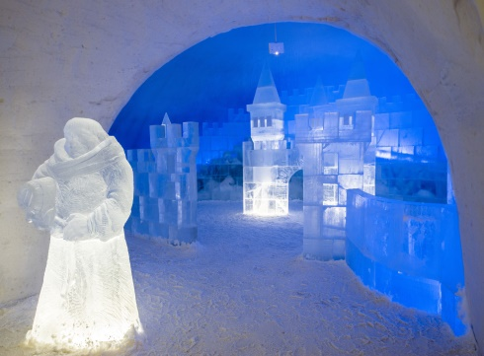 | Students of the class are listed.  Students' attention is drawn to the lesson.  Learners write the numbers from previous lesson  Determines the topic and purpose of the lesson  Students say different words from the picture | The teacher to assess learners for their ability.  “Good job!  Well done!”  Formative Assessment  Good job!  Descriptor:  -know key phrases  - can make sentence  - know vocabulary of previous lesson  Total: 1 point | Pictures
Middle of the lesson  Presentation part.  30 min | Ex:31 P:80  Ask the pupils to look at the pictures. Have a picture discussion.  Teacher: (pointing to the Bayterek Tower) What's this?  Pupil: The Bayterek Tower.  Teacher: It's a sculpture that looks like the Bayterek Tower. What is it a made of?  Pupil: Ice. etc  Ex: 32 P: 80  Explain the activity. The pupils read again the texts silently and complete the activity. Check their answers.  Ex: 1 P: 81  The pupils look at the pictures and circle the correct  Summative Assessment for the cross curricular unit  « Hot and cold» | Pupils listen and read.  ANSWERS  Students own answer  Pupils read and answer  ANSWERS  1 Every year in January and February.  2 Seventeen days.  3 Every year in December.  4 Ice bricks.  5 Animals, castles, fairy tale characters or famous buildings.  Pupils look, read and circle.  ANSWERS  1 blanket  2 campfire  3 whistle  4 fishing rod  5 penknife | Descriptor:  - look at the pictures  - listen and read  Total: 2 point  Descriptor:  - read again the texts silently  - answer the question  Total: 2 point  Descriptor:  - look, read and circle.  Total: 3 point  -Make CCQ questions Yes / No | Card  Worksheet  Students book
End of the lesson  5 min | FEEDBACK  Learners provide feedback on what they have learned at the lesson.  Ex:  Home task: |  |  | Poster Success

Short term plan: term 3

Unit 5: Hot and Cold |  | Lesson 40
Teacher name:

Date:
Grade: 4 |  | Number present: | absent:
Lesson title | Check point
Learning objectives | 4.2.7.1 contribute a growing range of suitable words, phrases, and sentences including giving opinions during short pair, group and whole class exchanges  4.3.3.1 recognise basic opinions in short, simple texts on an increasing range of general range of general and some curricular topics  4.4.5.1 link with some support sentences using basic coordinating connectors
Lesson objectives | Learners will be able to:  - revise talking about snow and ice
Value links | "Law and Order"  Observance of norms and rules of order and justice understand the need
Plan

Stages / Time | Teachers actions | Students actions | Assessment criteria | Resources
Beginning of the lesson  Warming-up  3 min  Pre-learning  «Brainstorming» method  7 min. | Organization moment :  1.Greeting.  Ask about the weather.  The teacher sets the lesson objectives, letting students know what to anticipate from the lesson.  Warming up  Where are you from?  How old are you?  What color is it?  How many students are there in class?  What day of the week today?  Revise the language of the previous lesson.  Lead – In | \  Students of the class are listed.  Students' attention is drawn to the lesson.  Learners write the numbers from previous lesson  Determines the topic and purpose of the lesson  Students say different words from the picture | The teacher to assess learners for their ability.  “Good job!  Well done!”  Formative Assessment  Good job!  Descriptor:  -know key phrases  - can make sentence  - know vocabulary of previous lesson  Total: 1 point | Pictures
Middle of the lesson  Presentation part.  30 min | Ex:1 P:81  The pupils look at the pictures and circle the correct words.  Ex: 2 P: 81  The pupils read and complete the sentences with the correct word  Ex: 3 P: 81  Nurlan wants to go camping with his family. What must/mustn't he do? Read and complete.  The pupils read and complete the sentences.  Ex: 3 P: 81  The pupils make sentences by putting the words in the correct order  Summative Assessment for the cross curricular unit  « Hot and cold»  Conclusion during the lesson some tasks differentiated by outcomes of the students and by their abilities. | Pupils look, read and circle.  ANSWERS  1 blanket  2 campfire  3 whistle  4 fishing rod  5 penknife  Pupils read and complete.  ANSWERS  1 snowing  2 raining  Pupils Nurlan wants to go camping with his family. What must/mustn't he do? Read and complete.  ANSWERS  1 mustn't  2 mustn't  3 mustn't  4 mustn't  5 must  Pupils make sentences.  ANSWERS  1 Can we visit the volcano?  2 He doesn't have to come with us.  3 Can I use your penknife?  4 We have to wash our clothes.  5 They don't have to get up early. | Descriptor:  - look, read and circle.  Total: 2 point  Descriptor:  - read and complete.  Total: 2 point  Descriptor:  - read and complete  Total: 2 point  Descriptor:  - make sentences  Total: 1 point  -Make CCQ questions Yes / No | Card  Worksheet  Students book
End of the lesson  5 min | FEEDBACK  Learners provide feedback on what they have learned at the lesson.  Ex:  Home task: |  |  | Poster Success

Short term plan: term 3

Unit 6: Healthy world |  | Lesson 41
Teacher name:

Date:
Grade: 4 |  | Number present: | absent:
Lesson title | Healthy bodies 1
Learning objectives | 4.2.5.1 clearly pronounce many words, short phrases and simple sentences;  4.4.7.1 write many common words correctly when doing written work on their own;
Lesson objectives | Learners will be able to:  - To talk about healthy bodies
Value links | "Law and Order"  Ensuring the protection and safety of society understand the importance of law and order as
Plan

Stages / Time | Teachers actions | Students actions | Assessment criteria | Resources
Beginning of the lesson  Warming-up  3 min  Pre-learning  «Brainstorming» method  7 min. | Organization moment :  1.Greeting.  Ask about the weather.  The teacher sets the lesson objectives, letting students know what to anticipate from the lesson.  Warming up  Where are you from?  How old are you?  What color is it?  How many students are there in class?  What day of the week today?  Revise the language of the previous lesson.  Lead – In  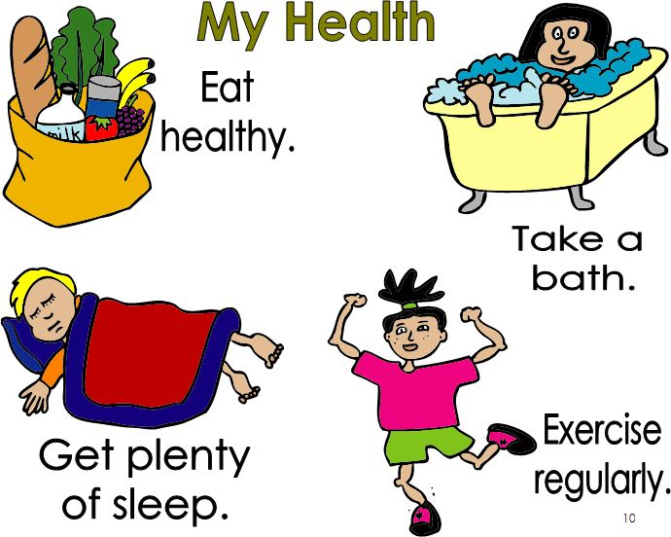 | Students of the class are listed.  Students' attention is drawn to the lesson.  Learners write the numbers from previous lesson  Determines the topic and purpose of the lesson  Students say different words from the picture | The teacher to assess learners for their ability.  “Good job!  Well done!”  Formative Assessment    Good job!  Descriptor:  -know key phrases  - can make sentence  - know vocabulary of previous lesson  Total: 1 point | Pictures
Middle of the lesson  Presentation part.  30 min | Ex:1 P:83  Say and write on the board: healthy eating. Elicit/explain what healthy eating means. Refer the pupils to the picture and have a picture discussion. Use the questions in the activity to elicit from the pupils orally where the children are, what they are doing, what they are eating and if the food is healthy. Then ask the pupils what they usually eat at school and elicit answers from individual pupils. Refer the pupils to the activity. Allow the pupil's some time to answer the questions. Check their answers.  Ex: 2 P: 83  Explain the activity. Go through the prompts and elicit/explain any unknown words. Allow the pupils some time to complete the activity. Check their answers.  Ex: 3 P: 83  Refer the pupils to the pictures. Explain that these are all ways to a healthy body. Read the example and explain the activity. Go through the prompts and elicit/explain any unknown words. Allow the pupils some time to complete the activity. Check them answers.  Ex: 4 P: 83  Ask the pupils, in pairs to write two more ways to a healthy body and draw pictures. Explain that they can use the sentences in Ex.3 as models. Allow the pupils some time to complete the activity. Ask each pair to present their projects to the class. | Pupils look at the picture. Answer the questions.  ANSWERS  1 at the school cafeteria  2 salad, sandwich, juice (suggested answers)  3 yes  4 fruit (suggested answer  Pupils read and choose. There are cap two extras.  ANSWERS  1.2.4  Pupils make sentences to complete the poster.  ANSWERS  2 Get active every day!  3 Sleep 10 hours!  4 Drink a lot of water!  Pupils in pairs, write two more ways to a healthy body. Draw pictures. Present them to the class.  ANSWERS  Students own answer | Descriptor:  - look at the picture.  - answer the questions.  Total: 2 point  Descriptor:  - read and choose  - complete the activity  Total: 2 point  Descriptor:  - make sentences  - complete the poster  Total: 3 point  -Make CCQ questions Yes / No | Students book
End of the lesson  5 min | FEEDBACK  Learners provide feedback on what they have learned at the lesson.  Ex:  Home task: |  |  | Poster Success

Short term plan: term 3

Unit 6: Healthy world |  | Lesson 42
Teacher name:

Date:
Grade: 4 |  | Number present: | absent:
Lesson title | Healthy food
Learning objectives | 4.​2.​6.​1 take turns when speaking with others in a growing range of short, basic exchanges;  4.​4.​2.​1 begin to use joined-up handwriting in a limited range of written work;  4.5.3.1 use adjectives, including possessive adjectives, on a growing range of general and some curricular topics to describe things, use simple one-syllable and
Lesson objectives | Learners will be able to:  -To talk about food and drinks
Value links | "Creativity and Innovation"  Monitoring, measuring, conducting experiments and experiments ability;
Plan

Stages / Time | Teachers actions | Students actions | Assessment criteria | Resources
Beginning of the lesson  Warming-up  3 min  Pre-learning  «Brainstorming» method  7 min. | Organization moment :  1.Greeting.  Ask about the weather.  The teacher sets the lesson objectives, letting students know what to anticipate from the lesson.  Warming up  Where are you from?  How old are you?  What color is it?  How many students are there in class?  What day of the week today?  Revise the language of the previous lesson.  Lead – In  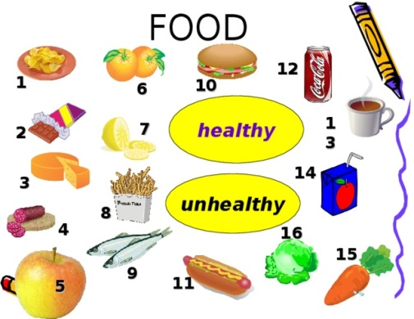 | Students of the class are listed.  Students' attention is drawn to the lesson.  Learners write the numbers from previous lesson  Determines the topic and purpose of the lesson  Students say different words from the picture | The teacher to assess learners for their ability.  “Good job!  Well done!”  Formative Assessment  Good job!  Descriptor:  -know key phrases  - can make sentence  - know vocabulary of previous lesson  Total: 1 point | Pictures
Middle of the lesson  Presentation part.  30 min | Ex:5 P:84  Put the Time to eat poster up on the board. Point to the items, one at a time, and say the corresponding phrases. The pupils repeat, chorally and/or individually. Point to each item in random order. Ask individual pupils to name the item. Explain to the pupils that in today's lesson you'll talk about food and drinks. Ask them to tell you their favourite food and drink  Ex: 6 P: 84  Refer the pupils to the pictures and elicit the names of the food items. Read the dialogue aloud and explain the activity. The pupils, in pairs, ask and answer questions, as in the example. Go around the classroom providing any necessary help. Ask some pairs to report back to the class.  Ex: 7 P: 85  Underline the words in bold. The pupils repeat, chorally and/or individually. Then say and write on the board: I am having a piano lesson this evening. Underline the words in bold. The pupils repeat, chorally and/or individually.  Ex: 8 P: 85  Refer the pupils to the pictures and elicit the words. Explain the activity. Play the CD. The pupils listen and match. Check their answers. Ask the pupils to tell you what each person is doing for tomorrow's party. | Pupils listen, point and repeat. Then match  ANSWERS  1 b  2 I  3 h  4 g  5 j  6 d  7 a  8 c  9 e  10  Pupils want to make a salad. Cap In pairs, decide what to include.  ANSWERS  A: Let's put some tomatoes in our salad.  B: Yes, sure. Why not?  A: Let's put some carrots in our salad.  B: Oh, no. Let's put some cucumbers.  A: Let's put some mayonnaise in our salad.  B: Yes, sure. Why not? etc  Pupils match. Then talk with your friend.  ANSWERS  2 a 3 b 4 e 5 c  A: What are you doing?  B: I'm going to the gym.  A: Going to the gym?  B: Yes. Exercising gives me more energy!  Pupils listen and match. Then say.  ANSWERS  1 Ayaulym  2 Karlygash  3 Bakhytzhan  4 Nurzhan | Descriptor:  - listen, point and repeat  - then match  Total: 2 point  Descriptor:  - make a salad.  - decide what to include  Total: 2 point  Descriptor:  - talk with your friend.  Total: 1 point  Descriptor:  - listen and match  Total: 1 point  -Make CCQ questions Yes / No | Card  Worksheet  Students book
End of the lesson  5 min | FEEDBACK  Learners provide feedback on what they have learned at the lesson.  Ex:  Home task: |  |  | Poster Success

Short term plan: term 3

Unit 6: Healthy world |  | Lesson 43
Teacher name:

Date:
Grade: 4 |  | Number present: | absent:
Lesson title | Snack Attack
Learning objectives | 4.1.10.1 the learner distinguishes words similar to words in the native language;  4.2.6.1 exchange replicas in simple dialogues on a wide range of topics;
Lesson objectives | Learners will be able to:  - To develop listening and reading comprehension skills through a story:  - to practise talking about plans and intentions;  - to learn how to distinguish between and pronounce the consonant clusters sk, sn and sp.
Value links | "Creativity and Innovation"  Ability to find optimal ways to solve educational tasks to use new and already familiar algorithms combining, using them in solving non-standard problems
Plan

Stages / Time | Teachers actions | Students actions | Assessment criteria | Resources
Beginning of the lesson  Warming-up  3 min  Pre-learning  «Brainstorming» method  7 min. | Organization moment :  1.Greeting.  Ask about the weather.  The teacher sets the lesson objectives, letting students know what to anticipate from the lesson.  Warming up  Where are you from?  How old are you?  What color is it?  How many students are there in class?  What day of the week today?  Revise the language of the previous lesson.  Lead – In   | Students of the class are listed.  Students' attention is drawn to the lesson.  Learners write the numbers from previous lesson  Determines the topic and purpose of the lesson  Students say different words from the picture | The teacher to assess learners for their ability.  “Good job!  Well done!”  Formative Assessment  Good job!  Descriptor:  -know key phrases  - can make sentence  - know vocabulary of previous lesson  Total: 1 point | Pictures
Middle of the lesson  Presentation part.  30 min | Ex:10 P:86  Play the CD. The pupils listen and follow the texts in their book.  Play the CD. The pupils listen and follow the texts in their books. Ask the pupils to tell you if they know any Play the CD. The pupils listen and follow the texts in their book.  Go through the pictures of the text and set the scene by asking the pupils questions about unusual snack, healthy snack and sweet snack.  Ex: 11 P: 87  Explain the activity. Refer the pupils to the summary and read the example aloud. Allow the pupils some time to read the story again silently and complete the summary. Check their answers.  Ex: 12 P: 87  Explain the activity. Allow the pupils some time to complete it. Check their answers.  Ex: 13 P: 87  Refer the pupils to the picture and the dialogue.The pupils, in pairs, act out similar dialogues. Go around the classroom providing any necessary help. Ask some pairs to come to the front of the classroom and act out the dialogue. If you wish, write the following on the board so the pupils can refer to it while they are completing the activity. | Pupils listen and read  ANSWERS  Students own answer  Pupils read the story and complete the summary.  ANSWERS  2 potatoes  3 stew  4 apples  5 Guy  6 gardening  Pupils choose the correct answer.  ANSWERS  B  Pupils talking point. Listen and read. Make a new dialogue with your friend.  ANSWERS  Gulnara: Hi, Berik. Where are you going?  Berik: To the supermarket. I want to buy some ho dogs and crisps for my birthday party.  Gulnara: Oh, is it tonight?  Berik: Yes. Are you coming?  Gulnara: Of course! What else are you planning fo your party?  Berik:My brother is decorating the house for us  Gulnara: Great! See you tonight, then. | Descriptor:  - listen, and read  Total: 2 point  Descriptor:  - read the story  - complete the summary  Total: 2 point  Descriptor:  - listen and read  - make a new dialogue  Total: 1 point  -Make CCQ questions Yes / No | Card  Worksheet  Students book
End of the lesson  5 min | FEEDBACK  Learners provide feedback on what they have learned at the lesson.  Ex:  Home task: |  |  | Poster Success

Short term plan: term 3

Unit 6: Healthy world |  | Lesson 44
Teacher name:

Date:
Grade: 4 |  | Number present: | absent:
Lesson title | Food and containers
Learning objectives | 4.1.10.1 the learner distinguishes words similar to words in the native language;  4.2.6.1 exchange replicas in simple dialogues on a wide range of topics;
Lesson objectives | Learners will be able to:  -To talk about food and containers.
Value links | "Creativity and Innovation"  Monitoring, measuring, conducting experiments and experiments ability;
Plan

Stages / Time | Teachers actions | Students actions | Assessment criteria | Resources
Beginning of the lesson  Warming-up  3 min  Pre-learning  «Brainstorming» method  7 min. | Organization moment :  1.Greeting.  Ask about the weather.  The teacher sets the lesson objectives, letting students know what to anticipate from the lesson.  Warming up  Where are you from?  How old are you?  What color is it?  How many students are there in class?  What day of the week today?  Revise the language of the previous lesson.  Lead – In  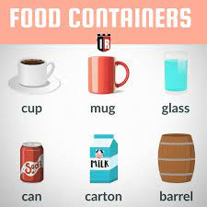 | Students of the class are listed.  Students' attention is drawn to the lesson.  Learners write the numbers from previous lesson  Determines the topic and purpose of the lesson  Students say different words from the picture | The teacher to assess learners for their ability.  “Good job!  Well done!”  Formative Assessment  Good job!  Descriptor:  -know key phrases  - can make sentence  - know vocabulary of previous lesson  Total: 1 point | Pictures
Middle of the lesson  Presentation part.  30 min | Ex:14 P:88  Pupils' books closed. Put the Snack Time poster up or the board. Point to the items, one at a time, and say the corresponding words. The pupils repeat, chorally and/or individually. Point to each item in random order. Ask individual pupils to name them.  Ex: 15 P: 88  Read aloud the example and explain the activity. Allow the pupils some time to complete it. Check their answers.  Ex: 16 P: 88  Refer the pupils to the pictures. Elicit healthy food and junk food. Ask them to say who eats healthy food and who eats junk food.  Ex: 17 P: 88  Explain the activity. Play the CD. The pupils listen and choose the correct picture. Check their answers. | Pupils listen, point and repeat. Which of these do you like? Which don't you like?  ANSWERS  I like chocolate, watermelon and crisps. I don't like peas and walnuts  Pupils read and choose the correct word.  ANSWERS  2 loaf  3 bottle  4 pot  5 carton  6 bar  7 packet  8 bottle  Pupils look at the trays. Who eats healthy food? Who eats junk food?  ANSWERS  Saule eats healthy food. Ulan eats junk food.  Pupils listen and choose the correct trays  ANSWERS  Saule: A  Ulan: B | Descriptor:  - listen, point and repeat.  -answer the question  Total: 2 point  Descriptor:  - read and choose  - complete the sentences  Total: 2 point  Descriptor:  - look at the trays  - answer the question  Total: 1 point  Descriptor:  - listen and choose the correct trays  Total: 1 point  -Make CCQ questions Yes / No | Card  Worksheet  Students book
End of the lesson  5 min | FEEDBACK  Learners provide feedback on what they have learned at the lesson.  Ex:  Home task: |  |  | Poster Success

Short term plan: term 3

Unit 6: Healthy world |  | Lesson 45
Teacher name:

Date:
Grade: 4 |  | Number present: | absent:
Lesson title | Study spot a and an
Learning objectives | 4.4.2.1 use of a continuous letter while performing a limited amount of written work;  4.5.9.1 use past tense forms to provide information about themselves and describe what they like, their preferences and habits, depict facts and events planned in the future, describe actions, feelings, and events;
Lesson objectives | Learners will be able to:  -To talk about food and containers.
Value links | "Creativity and Innovation"  Ability to find optimal ways to solve educational tasks to use new and already familiar algorithms combining, using them in solving non-standard problems
Plan

Stages / Time | Teachers actions | Students actions | Assessment criteria | Resources
Beginning of the lesson  Warming-up  3 min  Pre-learning  «Brainstorming» method  7 min. | Organization moment :  1.Greeting.  Ask about the weather.  The teacher sets the lesson objectives, letting students know what to anticipate from the lesson.  Warming up  Where are you from?  How old are you?  What color is it?  How many students are there in class?  What day of the week today?  Revise the language of the previous lesson.  Lead – In  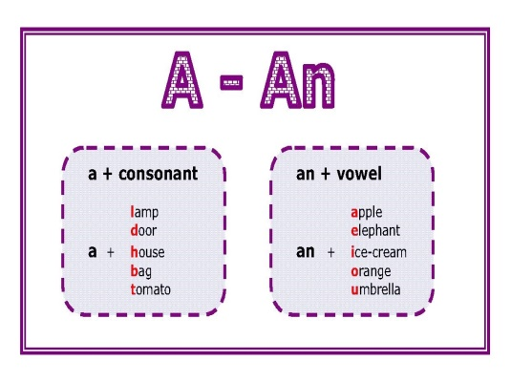 | Students of the class are listed.  Students' attention is drawn to the lesson.  Learners write the numbers from previous lesson  Determines the topic and purpose of the lesson  Students say different words from the picture | The teacher to assess learners for their ability.  “Good job!  Well done!”  Formative Assessment  Good job!  Descriptor:  -know key phrases  - can make sentence  - know vocabulary of previous lesson  Total: 1 point | Pictures
Middle of the lesson  Presentation part.  30 min | Ex: 18 P: 89  Pupils' books closed. Draw a potato on the board. Poin to it, say and write: a potato. Underline the article. The pupils repeat, chorally and/or individually. Draw an egg on the board. Point to it, say and write: an egg. Underline the article. The pupils repeat, chorally and/or individually Elicit the use of a before countable singular nouns tha begin with a consonant and the use of an before singular countable nouns that begin with a vowel.  Say and write on the board: There is some rice. Explain to the pupils that some nouns cannot be counted. (We cannot say one rice, two rices, etc). These words are only singular and are used with some.  Ex: 19 P: 89  Draw two eggs on the board. Say, then write: There are some eggs. Elicit the use of some for countable nouns in plural. Then write: Are there any eggs? There aren't any eggs. Elicit the use of some in the affirmative and any in the interrogative and in the negative. Say and write on the board: Is there any rice? There is some rice. There isn't any rice. Underline the words in bold and elicit the use of some in the affirmative and any in the negative and interrogative with uncountable nouns. Allow the pupils some time to read the sentences and complete the activity. Check their answers  Ex: 20 P: 89  Elicit the names of the food items depicted. The pupils look at the pictures and choose four items they have in their lunchboxes. Allow the pupils some time to complete the activity. Then individual pupils report back to the class. | Pupils write the words in the right box.  ANSWERS  some: honey, crisps, yogurt  an: apple, onion, orange  a: carrot, banana, potato  Pupils read and choose.  ANSWERS  2 any  3 any  4 any  5 any  6 some  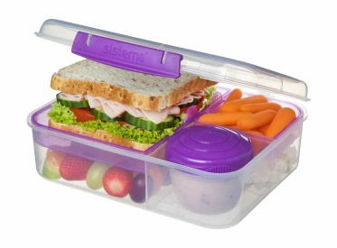  Pupils choose 4 food items. Tell the class.  ANSWERS  There's a burger, a tomato, some chocolate and an egg in my lunchbox. | Descriptor:  - write the words in the right box  Total: 1 point  Descriptor:  - read and choose  - complete the sentences  Total: 2 point  Descriptor:  - choose 4 food  - complete the activity.  Total: 1 point  -Make CCQ questions Yes / No | Card  Worksheet  Students book
End of the lesson  5 min | FEEDBACK  Learners provide feedback on what they have learned at the lesson.  Ex:  Home task: |  |  | Poster Success

Short term plan: term 3

Unit 6: Healthy world |  | Lesson 46
Teacher name:

Date:
Grade: 4 |  | Number present: | absent:
Lesson title | Healthy snacks
Learning objectives | 4.​4.​1.​1 plan, write and check sentences with support on a range of basic personal, general and some curricular topics;  4.​5.​1.​1 use singular nouns, plural nouns – including some common irregular plural – and uncountable nouns, possessive ‘s/s’ to name, describe and label things;
Lesson objectives | Learners will be able to:  - To revise food and healthy eating; to write a blog entry about healthy food; to develop the pupils' listening skills through a song.
Value links | "Creativity and Innovation"  Use of various cognitive tools, knowledge about the world be able to collect (linguistic, reading culture, information, service in the digital environment)
Plan

Stages / Time | Teachers actions | Students actions | Assessment criteria | Resources
Beginning of the lesson  Warming-up  3 min  Pre-learning  «Brainstorming» method  7 min. | Organization moment :  1.Greeting.  Ask about the weather.  The teacher sets the lesson objectives, letting students know what to anticipate from the lesson.  Warming up  Where are you from?  How old are you?  What color is it?  How many students are there in class?  What day of the week today?  Revise the language of the previous lesson.  Lead – In   | Students of the class are listed.  Students' attention is drawn to the lesson.  Learners write the numbers from previous lesson  Determines the topic and purpose of the lesson  Students say different words from the picture | The teacher to assess learners for their ability.  “Good job!  Well done!”  Formative Assessment  Good job!  Descriptor:  -know key phrases  - can make sentence  - know vocabulary of previous lesson  Total: 1 point | Pictures
Middle of the lesson  Presentation part.  30 min | Ex:21 P:90  Explain the activity. The pupils read the blog entries silently and complete them. Play the CD. The pupils listen and check their answers.  Ex: 22 P: 90  Explain the activity. Allow the pupils some time to complete it. Check their answers.  Ex: 25 P: 91  Present the British currency. Point to the coins and say the words. The pupils repeat after you. Explain that there are 100 pence in a pound. Refer the pupils to the picture and elicit the items. Read the example.The pupils act out similar exchanges. Go around the classroom providing any necessary help. Ask some pairs to report back to the class. | Pupils complete. Then listen and check. Which is your favourite snack?  ANSWERS  2 yogurt  3 walnuts  4 peanuts  5 peppers  6 carrots  Pupils read and match.  ANSWERS  1 c  2 a  3 b  4 d  Pupils read the example.  ANSWERS  A: Can I have a bar of chocolate and a packet of biscuits, please?  B: Here you are.  A: How much is that?  B: £2.30. etc | Descriptor:  - complete the sentences  -answer the question  Total: 2 point  Descriptor:  - read and match  - complete the sentences  Total: 2 point  Descriptor:  - read the example  Total: 1 point  -Make CCQ questions Yes / No | Card  Worksheet  Students book
End of the lesson  5 min | FEEDBACK  Learners provide feedback on what they have learned at the lesson.  Ex:  Home task: |  |  | Poster Success

Short term plan: term 3

Unit 6: Healthy world |  | Lesson 47
Teacher name:

Date:
Grade: 4 |  | Number present: | absent:
Lesson title | Time for CLIL. Save our animals1-2
Learning objectives | 4.3.2.1 read and understand short simple literary and popular scientific texts with little support;  4.4.5.1 connect sentences using basic phrases with little support
Lesson objectives | Learners will be able to:  To explore other subject areas (Geography); to talk about endangered animals; to make a poster for the protection of the rainforests
Value links | Integrity – Integrity is the quality of having strong moral principles. So, a person with integrity will always act with honesty and adhere to their own moral code regardless of what others do.
Plan

Stages / Time | Teachers actions | Students actions | Assessment criteria | Resources
Beginning of the lesson  Warming-up  3 min  Pre-learning  «Brainstorming» method  7 min. | Organization moment :  1.Greeting.  Ask about the weather.  The teacher sets the lesson objectives, letting students know what to anticipate from the lesson.  Warming up  Where are you from?  How old are you?  What color is it?  How many students are there in class?  What day of the week today?  Revise the language of the previous lesson.  Lead – In   | Students of the class are listed.  Students' attention is drawn to the lesson.  Learners write the numbers from previous lesson  Determines the topic and purpose of the lesson  Students say different words from the picture | The teacher to assess learners for their ability.  “Good job!  Well done!”  Formative Assessment  Good job!  Descriptor:  -know key phrases  - can make sentence  - know vocabulary of previous lesson  Total: 1 point | Pictures
Middle of the lesson  Presentation part.  30 min | Ex:26 P:92  Explain the activity. The pupils look at the pictures, read the sentences and say the names of the animals. Allow the pupils some time to complete the activity. Check their answers.  Ex:15 P:64 Ac B  Refer the pupils to the pictures and elicit the names of the animals. Explain the activity. Allow the pupils some time to read the sentences and match them with the correct pictures. Check their answers.  Ex: 27 P: 93  Refer the pupils to the dialogue. Play the CD. The pupils listen and follow along. Pause the CD for the pupils to repeat, chorally and/or individually. Refer the pupils to the pictures and elicit the names of the animals and what the pupils know about them. Read aloud the fact files. The pupils, in pairs, act out similar dialogues using the information in the fact files. Go around the classroom providing any necessary help. Ask some pairs to come to the front of the classroom and act out their dialogues. If you wish, write the following on the board so the pupils can refer to it while they are completing the activity | Pupils read and write  ANSWERS  1 rhino  2 gorilla  3 dolphin  4 polar bear  5 panda    Pupils read and match  ANSWERS  2 C  3 D  4 F  5 B  6 E  Pupils listen and read. Then act out similar dialogues.  ANSWERS  A: Look at these amazing chimpanzees. Where do chimpanzees live?  B: They live in the jungle. Did you know they are in danger?  A: Really? Why?  B: Because people hunt them or sell them as pets.  A: That's a shame. We must do something to protect them! | Descriptor:  - read and write  - say the names of the animals.  Total: 2 point  Descriptor:  - read the sentences  - match them with the correct pictures  Total: 2 point  Descriptor:  - listen and read.  - act out similar dialogues.  Total: 2 point  -Make CCQ questions Yes / No | Card  Worksheet  Students book
End of the lesson  5 min | FEEDBACK  Learners provide feedback on what they have learned at the lesson.  Ex:  Home task: |  |  | Poster Success

Short term plan: term 3

Unit 6: Healthy world |  | Lesson 48
Teacher name:

Date:
Grade: 4 |  | Number present: | absent:
Lesson title | Help the planet 1
Learning objectives | 4.1.4.1 understand a wide range of short normal questions related to general and academic topics with support;  4.2.6.1 exchange replicas in simple dialogues on a wide range of topics;
Lesson objectives | Learners will be able to:  To explore other subject areas (Geography); to talk about endangered animals; to make a poster for the protection of the rainforests
Value links | "Creativity and Innovation"  Monitoring, measuring, conducting experiments and experiments  ability;
Plan

Stages / Time | Teachers actions | Students actions | Assessment criteria | Resources
Beginning of the lesson  Warming-up  3 min  Pre-learning  «Brainstorming» method  7 min. | Organization moment :  1.Greeting.  Ask about the weather.  The teacher sets the lesson objectives, letting students know what to anticipate from the lesson.  Warming up  Where are you from?  How old are you?  What color is it?  How many students are there in class?  What day of the week today?  Revise the language of the previous lesson.  Lead – In   | Students of the class are listed.  Students' attention is drawn to the lesson.  Learners write the numbers from previous lesson  Determines the topic and purpose of the lesson  Students say different words from the picture | The teacher to assess learners for their ability.  “Good job!  Well done!”  Formative Assessment  Good job!  Descriptor:  -know key phrases  - can make sentence  - know vocabulary of previous lesson  Total: 1 point | Pictures
Middle of the lesson  Presentation part.  30 min | Ex:28 P:93  Explain the activity. Go through the sentences and elicit/explain any unknown words. Play the CD. The pupils listen and circle the correct words. Check their answers.  Ex: 29 P: 93  Design your own Save the rainforests! poster. Present it to the class.  Read aloud the title of the poster and have a class discussion about why we must save the rainforests. Read the instructions and explain the activity. Allow the pupils some time to prepare their posters. Ask individual pupils to present their poster to the class | Pupils read and circle. Then listen and check  ANSWERS  2 cold  3 South America  4 gen  5 smaller  Pupils design your own Save the rainforests!  Poster. Present it to the class.  ANSWERS  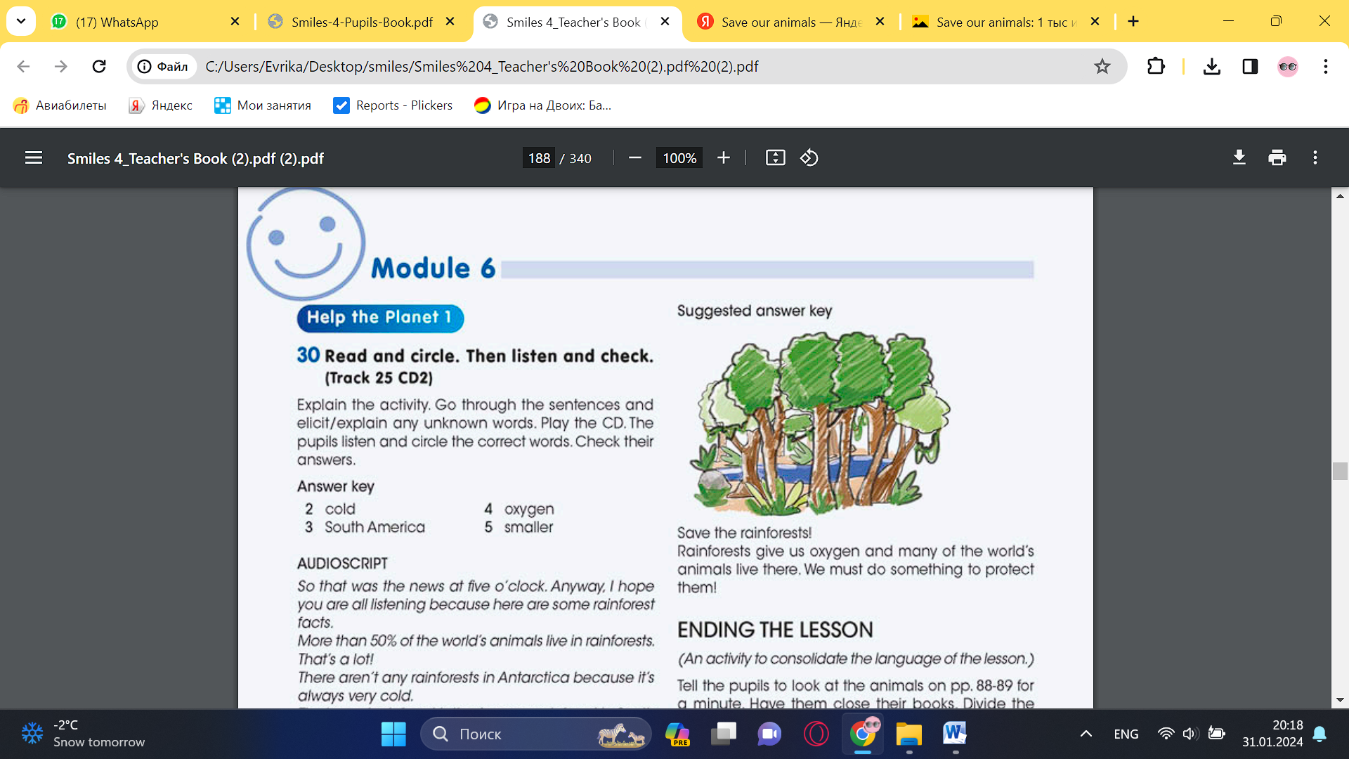  Save the rainforests! Rainforests give us oxygen and many of the world's animals live there. We must do something to protect them | Descriptor:  - read and circle.  - listen and circle the correct words.  Total: 2 point  Descriptor:  - design your own Save the rainforests  - present it to the class.  Total: 2 point  -Make CCQ questions Yes / No | Card  Worksheet  Students book
End of the lesson  5 min | FEEDBACK  Learners provide feedback on what they have learned at the lesson.  Ex:  Home task: |  |  | Poster Success

Short term plan: term 3

Unit 6: Healthy world |  | Lesson 49
Teacher name:

Date:
Grade: 4 |  | Number present: | absent:
Lesson title | Help the planet 2  Summative Assessment for the cross curricular unit «Healthy world»
Learning objectives | 4.1.3.1 understand the main ideas of short dialogues on a wide range of general and academic topics with support;  4.2.6.1 exchange replicas in simple dialogues on a wide range of topics;
Lesson objectives | Learners will be able to:  To explore other subject areas (Geography); to talk about endangered animals; to make a poster for the protection of the rainforests
Value links | "Creativity and Innovation"  Ability to find optimal ways to solve educational tasks to use new and already familiar algorithms combining, using them in solving non-standard problems
Plan

Stages / Time | Teachers actions | Students actions | Assessment criteria | Resources
Beginning of the lesson  Warming-up  3 min  Pre-learning  «Brainstorming» method  7 min. | Organization moment :  1.Greeting.  Ask about the weather.  The teacher sets the lesson objectives, letting students know what to anticipate from the lesson.  Warming up  Where are you from?  How old are you?  What color is it?  How many students are there in class?  What day of the week today?  Revise the language of the previous lesson.  Lead – In | Students of the class are listed.  Students' attention is drawn to the lesson.  Learners write the numbers from previous lesson  Determines the topic and purpose of the lesson  Students say different words from the picture | The teacher to assess learners for their ability.  “Good job!  Well done!”  Formative Assessment  Good job!  Descriptor:  -know key phrases  - can make sentence  - know vocabulary of previous lesson  Total: 1 point | Pictures
Middle of the lesson  Presentation part.  30 min | Ex:30 P:94  Explain the activity. Allow the pupils some time to complete it. Play the CD. The pupils listen and check their answers. Then ask the pupils if they know any other place or animal that is in danger. Elicit answers. Ask the pupils to say why this place/animal is in danger  Ex: 31 P: 94  Explain the activity. The pupils read the texts again silently and complete the activity. Check their answers. | Pupils read and complete. Then listen and check.  ANSWERS  2 danger  3 stones  4 litter  5 spots  6 mountains  7 fur  8 trees  Pupils read and complete.  ANSWERS  1 the air pollution from the traffic damages the stones  2 people hunted them for their fur or cut down the trees so they didn't have a home | Descriptor:  - read and complete.  - listen and check.  Total: 2 point  Descriptor:  - read and complete.  Total: 2 point  -Make CCQ questions Yes / No | Card  Worksheet  Students book
End of the lesson  5 min | FEEDBACK  Learners provide feedback on what they have learned at the lesson.  Ex:  Home task: |  |  | Poster Success

Short term plan: term 3

Unit 6: Healthy world |  | Lesson 50
Teacher name:

Date:
Grade: 4 |  | Number present: | absent:
Lesson title | Check point
Learning objectives | 4.​4.​1.​1 plan, write and check sentences with support on a range of basic personal, general and some curricular topics;  4.​5.​1.​1 use singular nouns, plural nouns – including some common irregular plural – and uncountable nouns, possessive ‘s/s’ to name, describe and label things;
Lesson objectives | Learners will be able to:  - Talk about healthy food
Value links | "Creativity and Innovation"  Use of various cognitive tools, knowledge about the world be able to collect (linguistic, reading culture, information, service in the digital environment)
Plan

Stages / Time | Teachers actions | Students actions | Assessment criteria | Resources
Beginning of the lesson  Warming-up  3 min  Pre-learning  «Brainstorming» method  7 min. | Organization moment :  1.Greeting.  Ask about the weather.  The teacher sets the lesson objectives, letting students know what to anticipate from the lesson.  Warming up  Where are you from?  How old are you?  What color is it?  How many students are there in class?  What day of the week today?  Revise the language of the previous lesson.  Lead – In  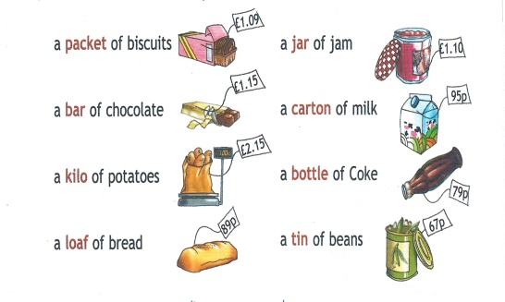 | Students of the class are listed.  Students' attention is drawn to the lesson.  Learners write the numbers from previous lesson  Determines the topic and purpose of the lesson  Students say different words from the picture | The teacher to assess learners for their ability.  “Good job!  Well done!”  Formative Assessment  Good job!  Descriptor:  -know key phrases  - can make sentence  - know vocabulary of previous lesson  Total: 1 point | Pictures
Middle of the lesson  Presentation part.  30 min | Ex:1 P:95  The pupils read and number the pictures.  Ex: 2 P: 95  The pupils read and underline the correct words.  Ex: 3 P: 95  The pupils read and complete the sentences with the correct word.  Ex: 4 P: 95  The pupils read and complete the sentences with the present continuous of the verbs in brackets. | Pupils number the pictures.  ANSWERS  a 3  b 2  c 4  d 5  e 0  f 1  Pupils read and underline  ANSWERS  1 loaf  2 pot  3 bars  4 bottles  5 carton  Pupils read and write. Use: some, any, a and an.  ANSWERS  1 any  2 any  3 an  4 some  5 a  Pupils read and complete the sentences.  ANSWERS  1 is cooking  2 are making  3 is climbing  4 are visiting  5 is buying | Descriptor:  - number the pictures.  Total: 2 point  Descriptor:  - read and underline  Total: 2 point  Descriptor:  - read and write  Total: 2 point  Descriptor:  - read and complete the sentences  Total: 2 point  -Make CCQ questions Yes / No | Card  Worksheet  Students book
End of the lesson  5 min | FEEDBACK  Learners provide feedback on what they have learned at the lesson.  Ex:  Home task: |  |  | Poster Success

Short term plan: term 3

Unit 6: Healthy world |  | Lesson 51
Teacher name:

Date:
Grade: 4 |  | Number present: | absent:
Lesson title | Presentation skills
Learning objectives | 4.3.2.1 read and understand short simple literary and popular scientific texts with little support;  4.4.5.1 connect sentences using basic phrases with little support
Lesson objectives | Learners will be able to:  - Talk about endangered animals.
Value links | "Creativity and Innovation"  Monitoring, measuring, conducting experiments and experiments  ability;
Plan

Stages / Time | Teachers actions | Students actions | Assessment criteria | Resources
Beginning of the lesson  Warming-up  3 min  Pre-learning  «Brainstorming» method  7 min. | Organization moment :  1.Greeting.  Ask about the weather.  The teacher sets the lesson objectives, letting students know what to anticipate from the lesson.  Warming up  Where are you from?  How old are you?  What color is it?  How many students are there in class?  What day of the week today?  Revise the language of the previous lesson.  Lead – In  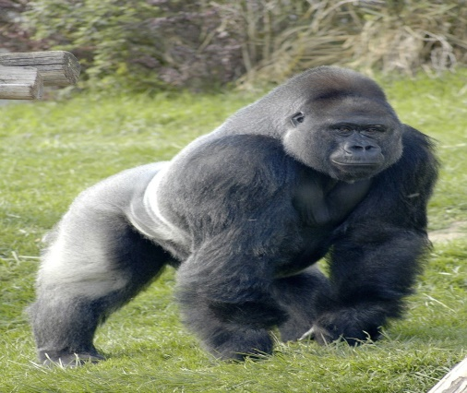 | Students of the class are listed.  Students' attention is drawn to the lesson.  Learners write the numbers from previous lesson  Determines the topic and purpose of the lesson  Students say different words from the picture | The teacher to assess learners for their ability.  “Good job!  Well done!”  Formative Assessment  Good job!  Descriptor:  -know key phrases  - can make sentence  - know vocabulary of previous lesson  Total: 1 point | Pictures
Middle of the lesson  Presentation part.  30 min | Ex:1 P:96  Read the title of the lesson. Ask the pupils if they have heard about endangered animals, and what they mean to them. Explain to the pupils, in LI if necessary, that some animals are in danger of becoming extinct for various reasons. Some animals are hunted by men. Other animals lose their homes and some others cannot find food any more.  Ex: 2 P: 95  Refer the pupils to the dialogue. Play the CD.The pupils listen and follow along. Pause the CD for the pupils to repeat, chorally and/or individually. Refer the pupils to the pictures and elicit the names of the animals and what the pupils know about them. Read aloud the fact files. Go around the classroom providing any necessary help. Ask some pairs to come to the front of the classroom and act out their dialogues. | Pupils read and complete Violet’s presentation. Then listen and check. How does Violet begin and end her presentation.  ANSWERS  2 to begin with today  3 Did you know  4 So, let’s see why  5 Another reason  6 I will leave today.  Pupils listen to Violet’s presentation again. Answer the question.  ANSWERS  1 there are only 700 gorills.  2 They live in mountain rainforests.  3 hunters kill the gorillas for food or to sell as souvenirs. People are chopping down the trees in the rainforests, in gorillas’ house. | Descriptor:  - read and complete Violet’s presentation  - listen and check  Total: 2 point  Descriptor:  - listen to Violet’s presentation again  - answer the question  Total: 2 point  -Make CCQ questions Yes / No | Card  Worksheet  Students book
End of the lesson  5 min | FEEDBACK  Learners provide feedback on what they have learned at the lesson.  Ex:  Home task: |  |  | Poster Success

Short term plan: term 2

Unit 6: Healthy world |  | Lesson 52
Teacher name:
Date:
Grade: 4 |  | Number present: | absent:
Lesson title | Tasks for the Summative Assessment for the term 3
Learning objectives | 4.1.3.1 understand the main ideas of short dialogues on a wide range of general and academic topics with support;  4.2.6.1 exchange replicas in simple dialogues on a wide range of topics;  4.3.2.1 read and understand short simple literary and popular scientific texts with little support;  4.4.5.1 connect sentences using basic phrases with little support
Lesson objectives | Learners will be able to:  - Read the text and answer the questions
Value links | "Creativity and Innovation"  Ability to find optimal ways to solve educational tasks to use new and already familiar algorithms combining, using them in solving non-standard problems
Plan

Stages / Time | Teachers actions | Students actions | Assessment criteria | Resources
Beginning of the lesson  Warming-up  3 min  Pre-learning  «Brainstorming» method  7 min. | Organization moment :  1.Greeting.  Ask about the weather.  The teacher sets the lesson objectives, letting students know what to anticipate from the lesson.  Warming up  Where are you from?  How old are you?  What color is it?  How many students are there in class?  What day of the week today?  Lead – In  Ask pupils to present their posters from the previous lesson.  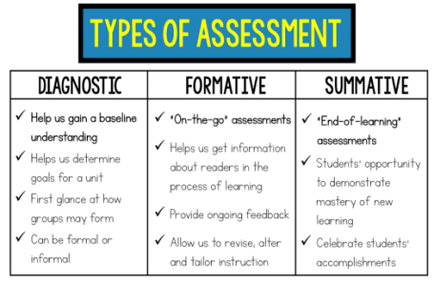 | Students of the class are listed.  Students' attention is drawn to the lesson.  Students analyze the given pictures in pairs.  Determines the topic and purpose of the lesson  Students say different words from the picture | The teacher to assess learners for their ability.  “Good job!  Well done!”  Formative Assessment  Good job! | Pictures
Middle of the lesson  Presentation part.  30 min | Listening  Task 1. Listen to the conversation carefully and complete the sentences. You will listen to the recording twice  Reading  Task 2. Read the text. Identify True and False sentences.  Writing  Task 3. Link the sentences. Fill in the gaps with connectors so, or, because, and. Use each connector only once  Speaking  Task 4. Work in pairs. Choose ONE picture. Look at the picture and talk to your classmate about it. Describe the picture, ask and answer questions  Conclusion during the lesson some tasks differentiated by outcomes of the students and by their abilities. | Pupils listen and write  ANSWERS  Pupils and answer the questions  Descriptor:  - read the text  Pupils put the letters in the correct order.  ANSWERS  Pupils tell about the places you lived  Descriptor:  - answer the questions. | Descriptor:  - listen and write  Total: 4 point  Descriptor:  - read the text  Total: 4 point  Descriptor:  - write sentences about the animal  Total: 4 point  Descriptor:  can answer the questions.  Total: 4 point | Card  Worksheet  Students book
End of the lesson  5 min | FEEDBACK  Learners provide feedback on what they have learned at the lesson.  Ex:  Home task: | 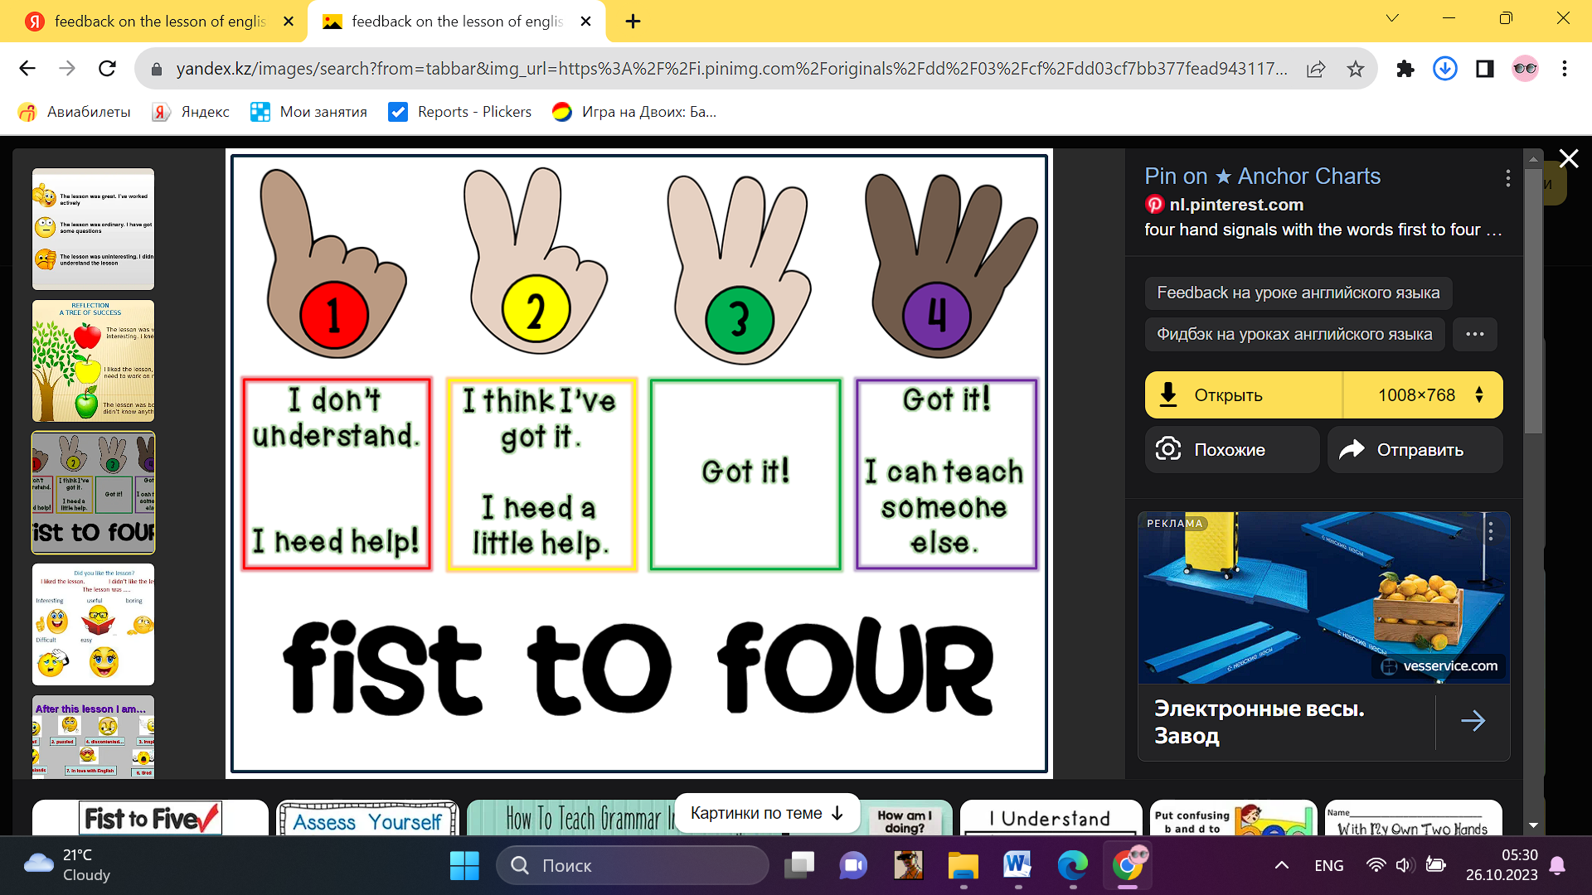 |  | Poster Success

Short term plan: term 3

Unit 6: Healthy world |  | Lesson 53
Teacher name:

Date:
Grade: 4 |  | Number present: | absent:
Lesson title | Story time
Learning objectives | 4.​3.​2.​1 read and understand with some support short simple fiction and non-fiction texts;  4.4.5.1 link with some support sentences using basic coordinating connectors
Lesson objectives | Learners will be able to:  - Talk about lazy people
Value links | "Creativity and Innovation"  Use of various cognitive tools, knowledge about the world be able to collect (linguistic, reading culture, information, service in the digital environment)
Plan

Stages / Time | Teachers actions | Students actions | Assessment criteria | Resources
Beginning of the lesson  Warming-up  3 min  Pre-learning  «Brainstorming» method  7 min. | Organization moment :  1.Greeting.  Ask about the weather.  The teacher sets the lesson objectives, letting students know what to anticipate from the lesson.  Warming up  Where are you from?  How old are you?  What color is it?  How many students are there in class?  What day of the week today?  Revise the language of the previous lesson.  Lead – In  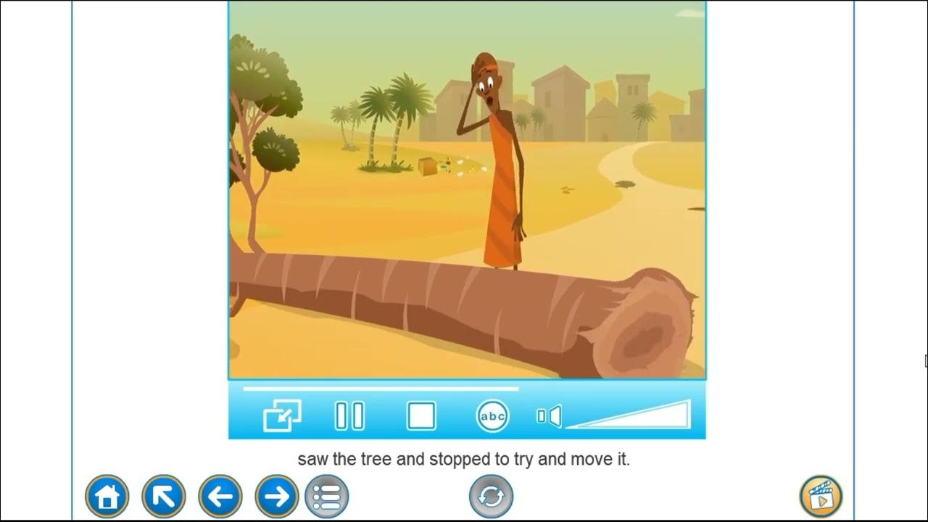 | Students of the class are listed.  Students' attention is drawn to the lesson.  Learners write the numbers from previous lesson  Determines the topic and purpose of the lesson  Students say different words from the picture | The teacher to assess learners for their ability.  “Good job!  Well done!”  Formative Assessment  Good job!  Descriptor:  -know key phrases  - can make sentence  - know vocabulary of previous lesson  Total: 1 point | Pictures
Middle of the lesson  Presentation part.  30 min | Ex:1 P:96  Go through the pictures of the story and set the scene by asking the pupils questions about what they can see in the pictures.  Play the CD. The pupils listen and follow the story in their books. Refer the pupils to the question and elicit the correct answer  Ex: 2 P: 97  The pupils read the story and the sentences. Then they match the sentences. Allow the pupils some time to complete the activity. Check their answers.  Play the CD again with pauses for the pupils to repeat, chorally and/or individually. Then ask individual pupils to read out the story. | Pupils listen and read. How does Afolabi teach the lazy people a lesson.  ANSWERS  Afolabi told his servants to dig a hole next to the tree and put a bag of gold in in, so Amaki, who tried to move this tree get that bag of gold.  Pupils read and choose  ANSWERS  1 A  2 B  3 A  4 A  5 A | Descriptor:  - listen and read  - answer the question  Total: 2 point  Descriptor:  - read and choose  Total: 2 point  -Make CCQ questions Yes / No | Card  Worksheet  Students book
End of the lesson  5 min | FEEDBACK  Learners provide feedback on what they have learned at the lesson.  Ex:  Home task: |  |  | Poster Success

Short term plan: term 3

Unit 7: Journey into Space |  | Lesson
Teacher name:

Date:
Grade: 4 |  | Number present: | absent:
Lesson title | Into Space 1
Learning objectives | 4.1.5.1 identify initial, middle and final phonemes and blends  4.5.5.1 use interrogative pronouns including: who, what, which, where, whose, how many, how much, how often, how big, what kind of … to ask questions on growing range of familiar topics  4.4.7.1 spell most familiar high-frequency words accurately when writing independently;
Lesson objectives | Learners will be able to:  - Talk about space
Value links | Integrity – Integrity is the quality of having strong moral principles. So, a person with integrity will always act with honesty and adhere to their own moral code regardless of what others do.
Plan

Stages / Time | Teachers actions | Students actions | Assessment criteria | Resources
Beginning of the lesson  Warming-up  3 min  Pre-learning  «Brainstorming» method  7 min. | Organization moment :  1.Greeting.  Ask about the weather.  The teacher sets the lesson objectives, letting students know what to anticipate from the lesson.  Warming up  Where are you from?  How old are you?  What color is it?  How many students are there in class?  What day of the week today?  Revise the language of the previous lesson.  Lead – In   | The aim: To develop pupils speaking skills and create friendly atmosphere  Efficiency: By wishing each other they feel better and feel the support of others  Students of the class are listed.  Students' attention is drawn to the lesson.  • Learners write the numbers from previous lesson  Determines the topic and purpose of the lesson  Students say different words from the picture | The teacher to assess learners for their ability.  “Good job!  Well done!”  Formative Assessment  Good job!  Descriptor:  -know key phrases  - can make sentence  - know vocabulary of previous lesson  Total: 1 point  Assessment criteria  - Learners have met the learning objectives if they can: To talk about healthy food | Pictures  worksheet  Student’s book
Middle of the lesson  Presentation part.  30 min | Ex:1 P:101  • Put the Journey into space poster up on the board. Point to the pictures, one at a time, and say the corresponding words. The pupils repeat, chorally and/or individually. Point to each picture in random order. Ask individual pupils to name them.  Refer the pupils to the picture on p.94 and have a picture discussion. Ask the pupils if they would like to travel into space and why. Elicit answers from individual pupils. Then say and write on the board: Earth. Explain to the pupils that Earth is the name of our planet. Ask the pupils to name other planets (Mercury. Venus, Mars, Jupiter, Saturn, Uranus and Neptune). Then ask them to name the planets that are bigger than Earth.  Ex: 2 P: 101  • Explain the activity. Allow the pupils some time to match the pictures with the correct words. Play the CD. The pupils listen and check their answers.  Ex: 3 P: 101  • Explain the activity. Go through the sentences and elicit/explain any unknown words. Allow the pupils some time to complete the activity. Check their answers.  Ex: 4 P: 101  • Refer the pupils to the picture and have a picture discussion. Read the example aloud and explain the activity. Allow the pupils some time to look at the picture and complete the activity. Ask individual pupils to answer. Ask the rest of the class for verification.  Conclusion during the lesson some tasks differentiated by outcomes of the students and by their abilities. | Pupils look at the picture. Would you like to travel into space? Why?/Why not? Do you know any planets bigger than Earth?  ANSWERS  I would like to travel into space to visit other planets. (suggested answer) Jupiter, Saturn, Uranus and Neptune are bigger than Earth.  Pupils can you find these in the picture. Match. Then listen and check.  ANSWERS  2 I 3 h 4 f 5 d 6 b 7 g  8 e 9 c  Pupils read and write.  ANSWERS  2 spaceship  3 spacesuit  4 telescope  6 alien  5 space station  Pupils look and read. Write yes or no.  ANSWERS  2 no  3 no  4 yes  5 no | Descriptor:  - look at the picture  - answer the question  Total: 2 point  Descriptor:  - find these in the picture  - match the pictures with the correct words  Total: 2 point  Descriptor:  - read and write  Total: 2 point  Descriptor:  - look and read  - write yes or no  Total: 2 point  -Make CCQ questions Yes / No | Card  Worksheet  Students book
End of the lesson  5 min | FEEDBACK  Learners provide feedback on what they have learned at the lesson.  Ex:  Home task: |  |  | Poster Success

